**React Native Installation**

Youtube Links : <https://www.youtube.com/watch?v=UwFFsS33xG8>

Official Link : <https://reactnative.dev/docs/environment-setup>

Step 1 :

* Install Node

Link : <https://nodejs.org/en/download>

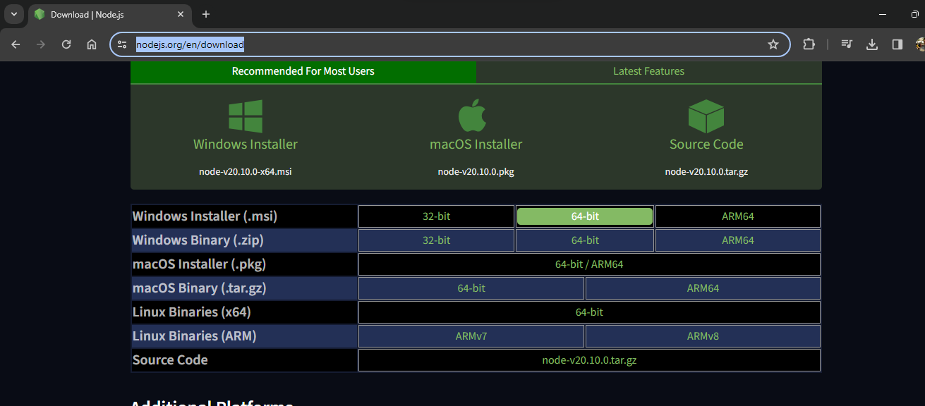

* Check Installation

**>>> node --version**

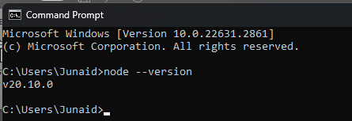

Step 2 :

* **Download & install Java JDK** ( before download javaJDK Check the Supported version in react native official link )

**Link :** [**https://www.openlogic.com/openjdk-downloads?field_java_parent_version_target_id=807&field_operating_system_target_id=436&field_architecture_target_id=391&field_java_package_target_id=396**](https://www.openlogic.com/openjdk-downloads?field_java_parent_version_target_id=807&field_operating_system_target_id=436&field_architecture_target_id=391&field_java_package_target_id=396)

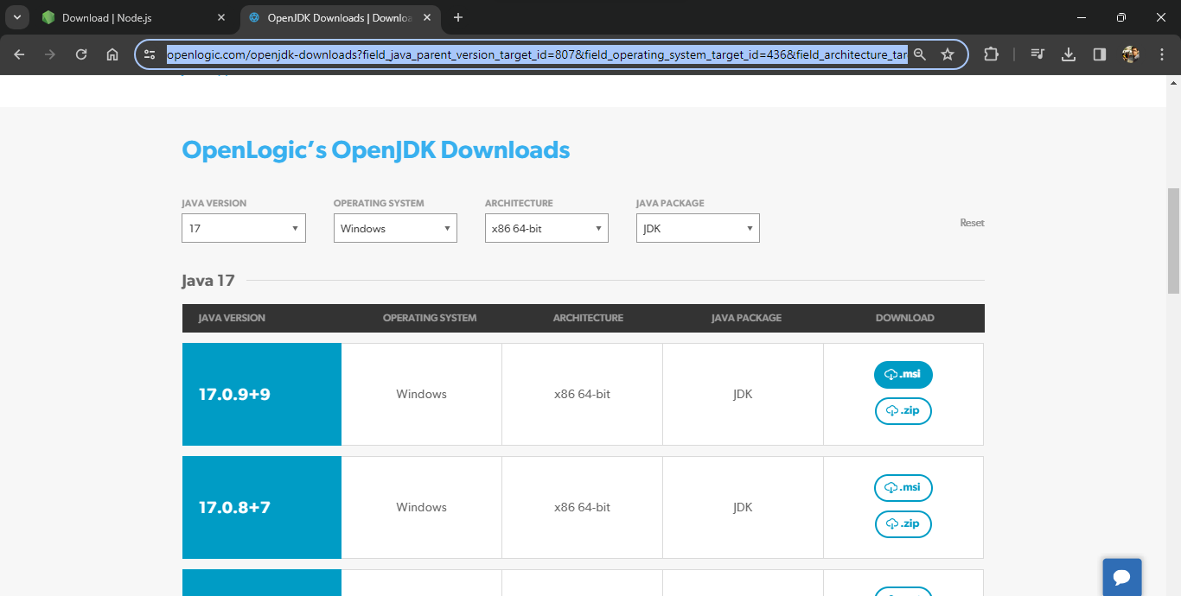

* Check Installation

**>>> java --version**

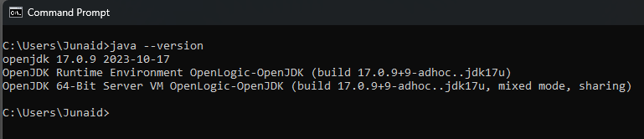

Step 3 :

* Set **JAVA_HOME** path

Goto this path according to your system

**C:\Program Files\OpenLogic\jdk-17.0.9.9-hotspot**

* Open Enviroment Variable

Press win key and Search **Enviroment variable**

* Goto Enviroment Variable



* Set The Above path in **( User Variable )** and **( System Variable )**

1 – Set **JAVA_HOME** in ( user variable )

Click on New add these

Variable Name : **JAVA_HOME**

Variable Value : **C:\Program Files\OpenLogic\jdk-17.0.9.9-hotspot**

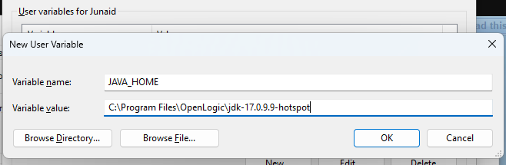

2 – Set **JAVA_HOME** in ( System variable )

Click on New Add These

Variable Name : **JAVA_HOME**

Variable Value : **C:\Program Files\OpenLogic\jdk-17.0.9.9-hotspot\**

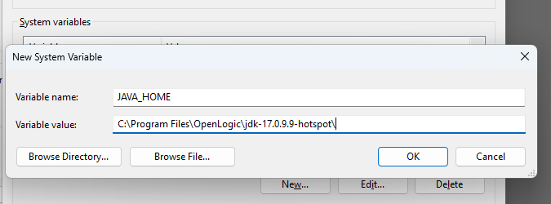

3 – Set Path on System Variable

* Select Path and click on Edit

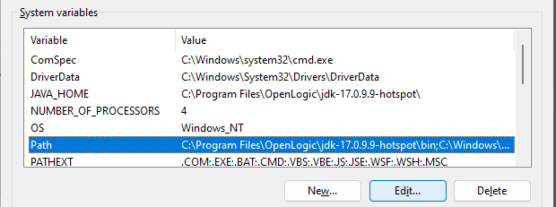

Add this path

C:\Program Files\OpenLogic\jdk-17.0.9.9-hotspot\bin

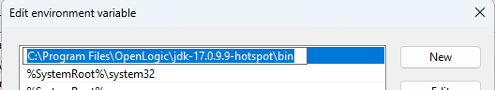

Step 4 :

* Download and Install **Android Studio**

Link : <https://developer.android.com/studio?gclid=CjwKCAiAnL-sBhBnEiwAJRGigsGeqSSb_xsKqRACnSLgewTTc4Q7LeVJp9ck_7tyZKGKRXsclurighoCqpoQAvD_BwE&gclsrc=aw.ds>

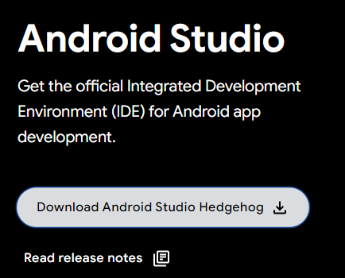

* Select agreement and click on download

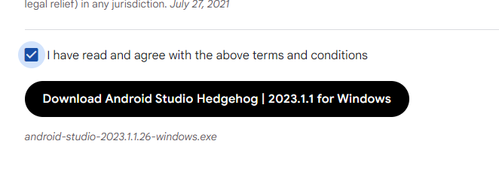

* Install android Studio with default settings

**Stop when you see this screen**

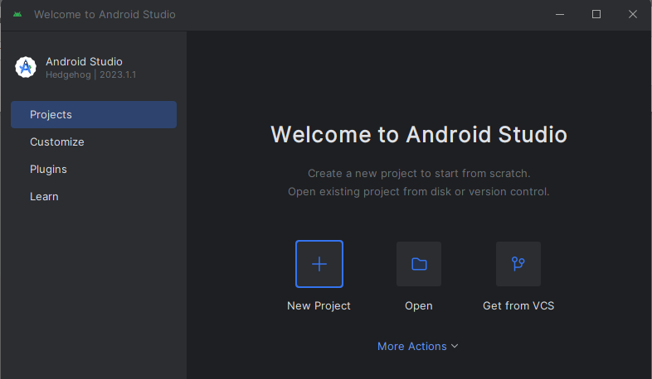

* Click on **More Action** and Select **SDK Manager**

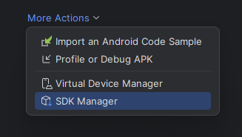

* In **SDK Platform**

Always selecet one version lower also

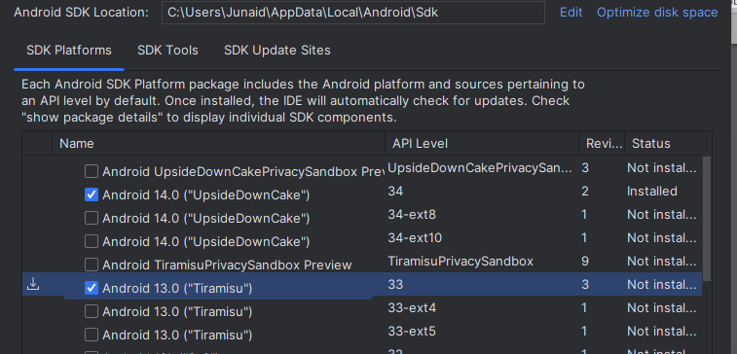

* In **SDK Tools**

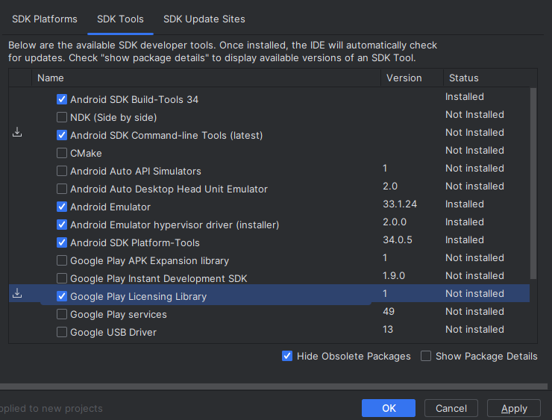

Select These and click on Apply it will download all the dependencies and press ok

Step 5 :

* Setup **Android path**

Open SDK Manager Again and find the SDK Path

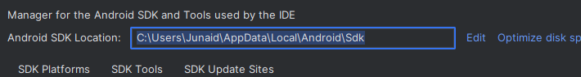

**C:\Users\Junaid\AppData\Local\Android\Sdk**

1 – Setup **ANDROID_HOME**

Open Enviroment variable

Set this path in **( User Variable and )** and **( System Variable )**

Variable Name : **ANDROID_HOME**

Varibale Value : **C:\Users\Junaid\AppData\Local\Android\Sdk**

Click **New**

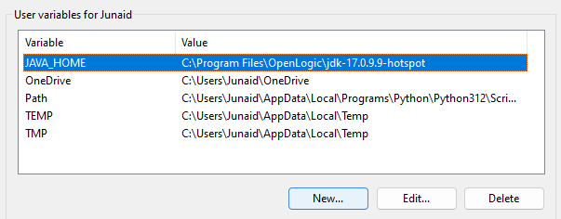

* Add in **(User Variable )**

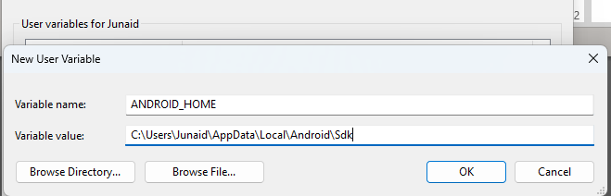

* Also add in **( System variable )**

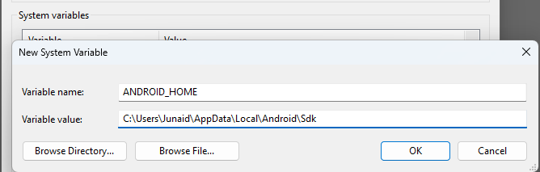

2 – Setup Paths in **( User Variable and )** and **( System Variable )**

These are the path

**C:\Users\Junaid\AppData\Local\Android\Sdk**

**C:\Users\Junaid\AppData\Local\Android\Sdk\platform-tools**

**C:\Users\Junaid\AppData\Local\Android\Sdk\emulator**

* Add in **(User Variable )**

Select path and click on Edit

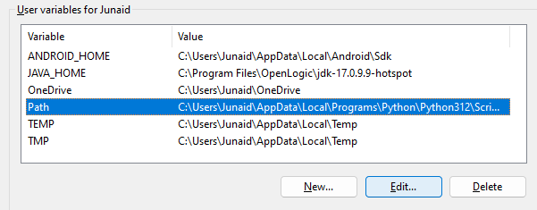

Add these path and press ok

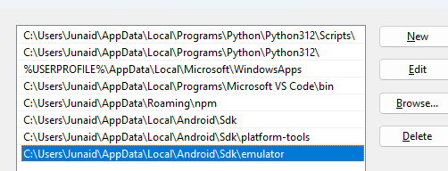

* Also add in **( System variable )**

Select path and click on Edit

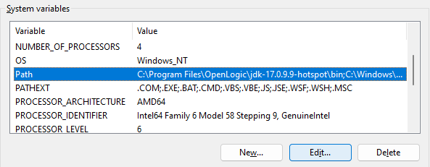

Add these path and press ok

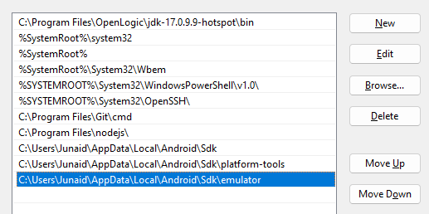

Press OK And Close All Envirment Variable Windows

Step 6 :

* Create and run React Native Project

>>> npm install -g [npm@10.2.5](mailto:npm@10.2.5)

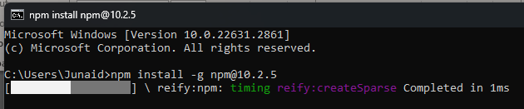

* Create a Folder Name Projets on Desktop

Open Terminal from this path

**>>> npx react-native init myproject**

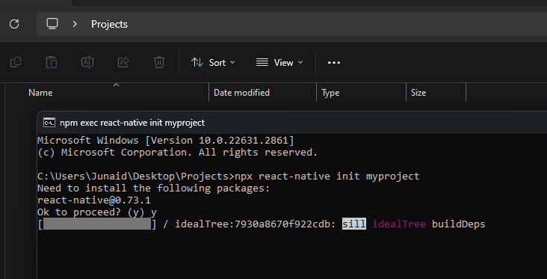

**>>> cd myproject**

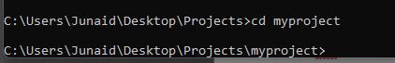

**>>> npm install**

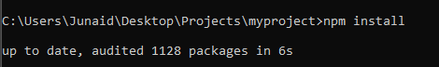

**Node :** Connect your device with ( enabled debugging mode )

**>>> npm start**

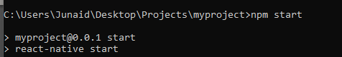

**Press a for Android**

